# Open Banking Query Tool

## The Purpose

Banking customers regularly have queries about their accounts that cannot be easily answered using existing applications. This results in large call centers fielding many customer calls throughout the year. Natural language AI agents offer the potential to enable customers to self serve by asking natural language questions of the AI Agent and using the APIs exposed through the Payment Services Directive 2 (PSD2) APIs.

## The Challenge

Accessing the Open Banking APIs directly would create an unacceptable load on the real transactional systems so Ostia have created a Digital Twin of the Open Banking Implementation Entity’s (OBIE) standard APIs. This Digital Twin is populated with data from the back office banking systems and is then used by AI to deliver the service directly to customers.

## The Configuration

Ostia have built an Open Banking Digital Twin using our No-code API EcoSystem (N-CAPIE) tool which implements a fully compliant version of the OBIE Accounts and Transactions APIs. This is populated using data from the existing systems to ensuring there is no additional load on the existing systems.

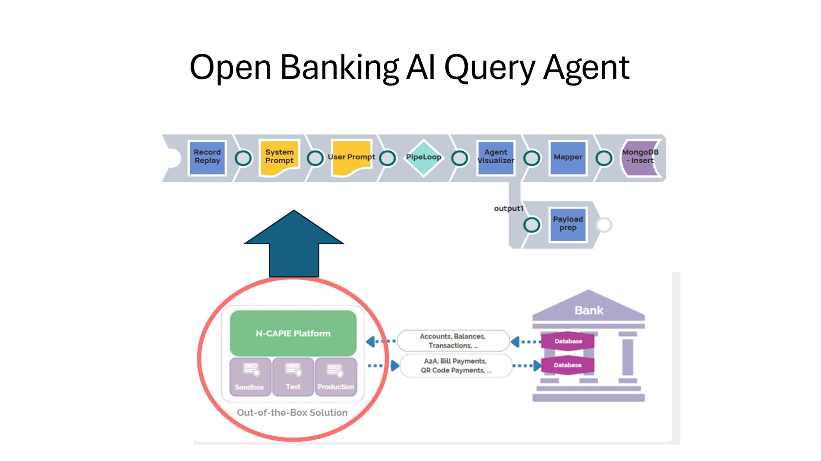

## Sample Queries

1. Show me any transactions with a value greater than 50 USD.
2. Show all direct debits and standing orders greater for a value greater than 200 USD.
3. Show all transactions in the month of July.